**DCS F-4E PILOT & WSO Profiles for TM Hotas Warthog**

* Functional layout
* Modifiers for Pilot & WSO
* TrackIR required
* Rudder pedals required

**v1.0** =< GreaseLitenin >=

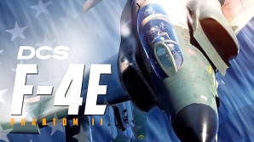

|  |  |
| --- | --- |
| **Controls Indicator** | RCtrl + Enter |
| **Framerate** | RCtrl + Pause |
| **Time Acc Time Dec Time Norm** | LCtrl + Z  LAlt + Z  LShift + Z |
| **Act Pause**  **Pause** | LShift + Win + Pause  Pause |
| **Info Bar**  **Labels** | LCtrl + Y  LShift + F10 |
| **Briefing** | LAlt + B |
| **F10 Map Coords**  **Formats**  **Tag/Copy** | LAlt + Y  LAlt + L Mouse Click |
| **Bombing Table** | RCtrl + B |
| **Refuel Rearm Window** | LAlt + ‘ |

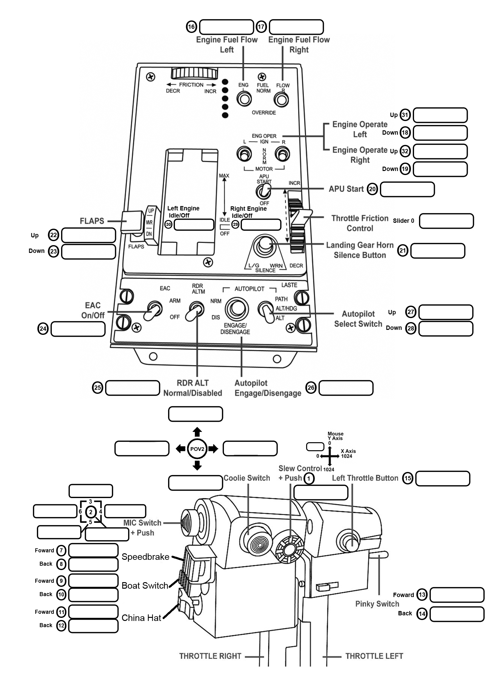

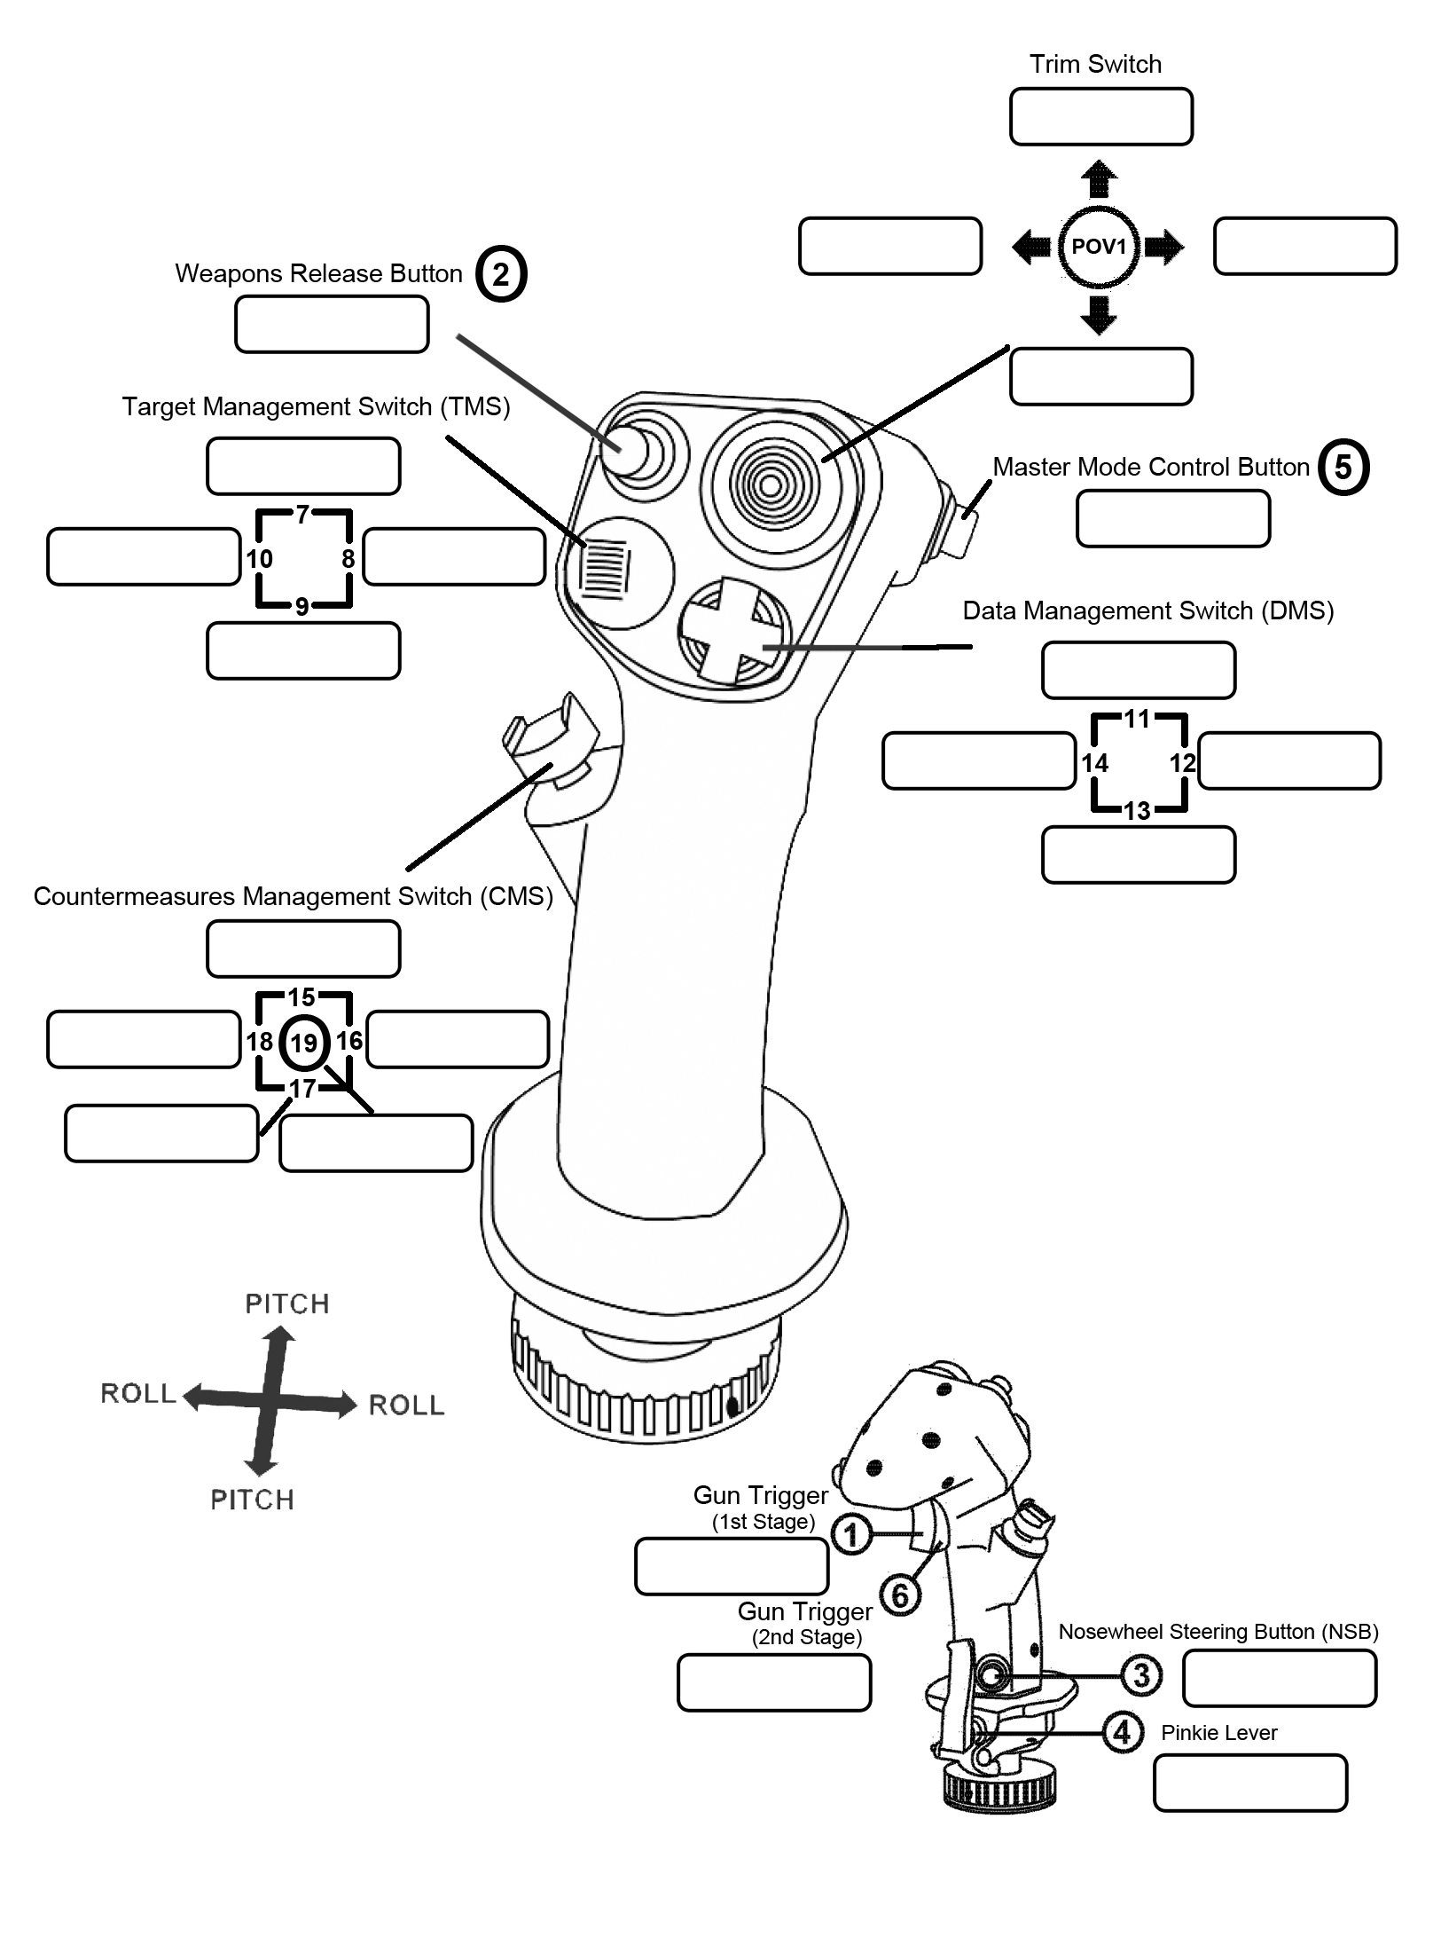

**TRIM R WING DN**

**NEAREST AC VIEW**

**TRIM L WING DN**

**WPN TO TGT VIEW**

**EMERG QUICK REL**

**NVG**

**TRIM**

**VIEWS**

|  |  |  |  |
| --- | --- | --- | --- |
| **16** | **RDR MSL**  **↑CW ON**  **↓STBY ↓OFF** | **17** | **INTLK**  **↑IN**  **↓OUT** |

**TRIM NOSE DN**

**COCKPIT VIEW**

|  |  |  |  |
| --- | --- | --- | --- |
| **Left** | **Up** | **31** | **AFCS ENGAGE (Toggle)** |
| **Dn** | **18** | **L ENG IGNITION** |
| **Right** | **Up** | **32** | **ALT ENGAGE (Toggle)** |
| **Dn** | **19** | **R ENG IGNITION** |

**TRIM NOSE UP**

**OWN AC VIEW**

**BOMB RELEASE**

**ANTENNA HAND CONTROL (AHC)**

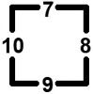

**AHC SLEW UP**

**ANT ELEV UP**

**AHC SLEW L**

**AHC TRIGGER  
HALF ACTION**

**AHC SLEW DN**

**ANT ELEV DN**

**AHC SLEW R  
AHC TRIGGER  
FULL ACTION**

|  |  |
| --- | --- |
| **20** | **AUTO PROCEDURE**  **↑STARTUP ↑SHUTDOWN** |

**GUN/MSL REJECT**

**WSO SEAT**

**PILOT SEAT**

|  |  |  |
| --- | --- | --- |
| **FLAPS / SLATS** | | |
| **Up** | **22** | **NORM** |
| **Mid** | **-** | **OUT** |
| **Dn** | **23** | **OUT & DN** |

|  |  |
| --- | --- |
| **Slider 0** | **-** |

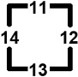

**WPN SEL CCW**

**KNEEBD PREV PG**

**WPN SEL CW  
KNEEBD NEXT PG**

**DELIVERY MODE CCW**

**KNEEBD MAP MARK**

**DELIVERY MODE CW**

**KNEEBD**

**WEAPON SELECT, DELIVERY MODE**

**KNEEBOARD**

|  |  |
| --- | --- |
| **21** | **LDG GEAR UP/DN**  **BOMBING TABLE** |

|  |  |  |
| --- | --- | --- |
| **DSCG** | | |
| **Up** | **27** | **RADAR** |
| **Mid** | **-** | **OFF** |
| **Dn** | **28** | **TV** |

**MASTER**

**↑ ARM**

**↓ SAFE**

**AIR REFUELING RELEASE WHEEL BRAKES**

**HUD MODE**

**WHEEL BRAKE R**

**HUD MODE CW**

**WHEEL BRAKE L**

**HUD MODE CCW**

**-**

**WHEEL BRAKE BOTH**

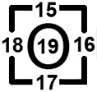

**ARR**

**GUN RATE**

**↑ HIGH**

**↓ LOW**

* AIM-9 Seeker

Uncage (hold)

* Maverick FHC

Slew (hold) /

Lock (release)

|  |  |
| --- | --- |
| **COMMANDS LEGEND** | |
| PILOT  only | **DEFAULT** |
| **MODIFIER** |
| PILOT  & WSO | **DEFAULT** |
| **MODIFIER** |
| WSO  only | **MODIFIER** |

**SUNGLASSES**

**VISOR**

STICK

**WPN FHC SLEW L**

**NVG GAIN DN**

**WPN FHC SLEW R**

**NVG GAIN UP**

**FORWARD HAND CONTROL ZOOM, NVG GAIN**

**WPN FHC SLEW UP**

**ZM IN SLOW**

**WPN FHC SLEW DN**

**ZM OUT SLOW**

**FLT ATTK AIR DEFENSES**

**FLT ATTK GRND TGTS**

**JESTER**

**MIC**

**COMMS**



**JESTER CONTEXT ACTION (short, hold, double-click)**

**JESTER UI ACTION**

**(short, hold)**

**MIC ICS**

**COVER ME**

**MIC UHF**

**FLT ENGAGE BANDITS**

**AWACS BOGEY DOPE**

**JESTER MAIN MENU**

**MODIFIER**

**Button**

(unassign slew axes)

**Slew Control + Push**

|  |
| --- |
| **1ST STAGE** |
| **TRIGGER HALF ACTION** |

|  |
| --- |
| **TRACK IR RECENTER** |

|  |  |  |
| --- | --- | --- |
| **Fwd** | **7** | **SPD BRAKE IN**  **SEAT DN** |
| **Aft** | **8** | **SPD BRAKE OUT (Hold)**  **SEAT UP** |
| **Fwd** | **9** | **RADAR** |
| **Mid** | **-** | **HEAT** |
| **Aft** | **10** | **GUN**  **ARM/DISARM GUN** |
| **Fwd** | **11** | **CAGE**  **ACTIVE PAUSE** |
| **Aft** | **12** | **CHAFF/FLARE**  **BRIEFING** |

|  |  |
| --- | --- |
| **LSO/AirBoss View** | LAlt/RAlt + F9 |
| **AirBoss Move/Click** | WASD QE/LAlt C |
| **Catapult Camera** | RCtrl + F9 |
| **Catapult Crew View** | RAlt + RCtrl + F9 |
| **Ship View** | F9 |

Allow Airboss/

LSO in ME & choose them in slot

|  |
| --- |
| **2ND STAGE** |
| **TRIGGER FULL ACTION**  **CONTROLS INDICATOR** |

**NOSE GEAR STEER**

**/ AUTO ACQ**

**AHC CHALLENGE**

**Coolie Switch**

|  |  |  |
| --- | --- | --- |
| **Pinky**  **Switch** | | **AIR REFUEL /**  **DRAG CHUTE** |
| **Fwd** | **13** | **AR SWITCH EXT** |
| **Mid** | **-** | **AR SWITCH RET /**  **DRAG CHUTE IN** |
| **Aft** | **14** | **DRAG CHUTE DEPLOY** |

**Speedbrake**

**Boat Switch**

**China Hat**

THROTTLE

THROTTLE